**DAILY ONLINE ACTIVITIES SUMMARY**

|  |  |  |  |  |  |  |  |  |
| --- | --- | --- | --- | --- | --- | --- | --- | --- |
| **Date:** | **17/06/2020** | | | | | **Name:** | **Lavanya D M** | |
| **Sem & Sec** | **4th & ‘A’** | | | | | **USN:** | **4al18cs041** | |
| **Online Test Summary** | | | | | | | | |
| **Subject** | | **nil** | | | | | | |
| **Max. Marks** | | **nil** | | **Score** | | | **nil** | |
| **Certification Course Summary** | | | | | | | | |
| **Course** | **Accettare Bitcoin nella tua azienda** | | | | | | | |
| **Certificate Provider** | | | **Bitdegree** | | **Duration** | | | **48hrs** |
| **Coding Challenges** | | | | | | | | |
| **Problem Statement:1)** Write a C Program to Count numbers that don’t contain 3  2)Java program to find the curved surface area of cube | | | | | | | | |
| **Status: complied** | | | | | | | | |
| **Uploaded the report in Github** | | | | | **yes** | | | |
| **If yes Repository name** | | | | | <https://github.com/lavanyamurthi/lockdown-coding> | | | |
| **Uploaded the report in slack** | | | | | **yes** | | | |

Online Test Details: (Attach the snapshot and briefly write the report for the same)

Certification Course Details: (Attach the snapshot and briefly write the report for the same)



Coding Challenges Details: (Attach the snapshot and briefly write the report for the same)

**Problem 1:** Write a C Program to Count numbers that don’t contain 3

Given a number n, write a function that returns count of numbers from 1 to n that don’t contain digit 3 in their decimal representation.  
**Examples:**  
**Input:** n = 10  
**Output:** 9  
Here input is 10 means the numbers within 10 are 1,2,3,4,5,6,7,8,9,10 in this series 3 occurs only 1 times so answer is 9

**More examples**  
Input: n = 45  
Output: 31  
// Numbers 3, 13, 23, 30, 31, 32, 33, 34,  
// 35, 36, 37, 38, 39, 43 contain digit 3.

Input: n = 578  
Output: 385

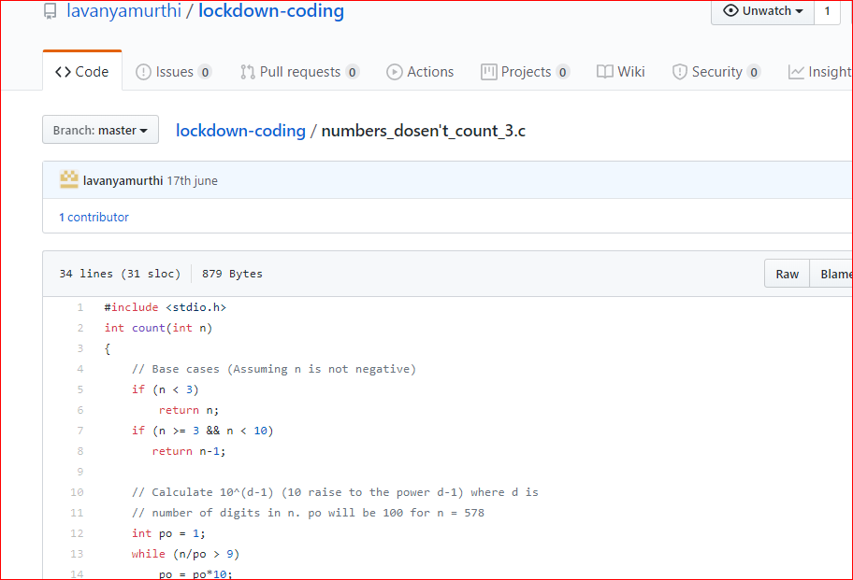

**Problem 2: Java program to find the Curved Surface Area Of Cube**

